Name (first and last): _________________________________ Period:_________
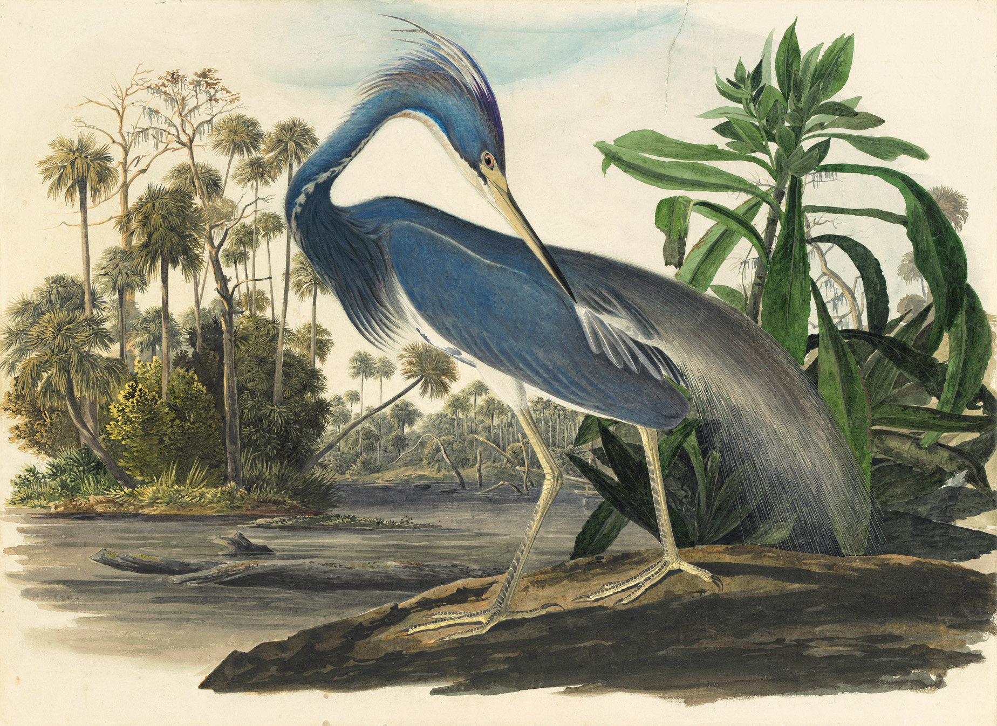
Directions: Choose three compositional strategies from the list provided below. Using complete sentences, write about how and why the artist specifically incorporated them into the painting.

[Emphasis, Rule of Thirds, Leading Lines, Strong Diagonal, Line of Sight, Point of View, Framing, Filling the Frame]
Audubon did single page paintings of each bird in his collection for Birds of America, this piece obviously being dedicated to this species of heron. By having the blue heron isolated in the middle of the page as the only turquoise blue hue in the painting, the heron becomes the focal point of the piece. The shapes of the bird’s body act as a series of leading lines that cause us to study the heron more closely. The legs lead up to the head, which leads down to the body, and on and on. The leaves of the bush behind the heron act as similar leading lines pointing to the bird. The bird’s neck curves around, and the bird is looking at itself, demonstrating line of sight. The bird leads us back to the area of emphasis when doing this. The bird/focal area is also effectively framed by the landscape around it, silhouetting its unique blue against the clear negative space of the sky.
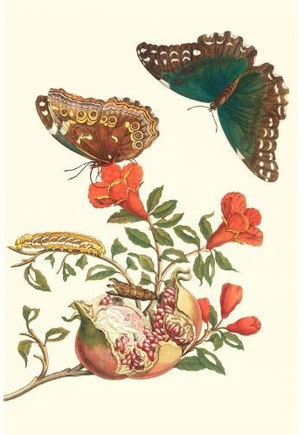
Directions: Using complete sentences, explain why the artist may have used the Rule of Odds or Simplifying in order to create this painting.
This piece by Merian uses Simplifying, because the main subject of the flora and fauna is silhouetted against a neutral background. Because this piece is as much about science as it is about design, the simple/clear figures are more easily appreciated for their unique details and able to be studied closely without distractions.
Directions: Draw the animal from the illustration provided. Use your drawing steps and do not erase them. Finish the planar analysis and value using mark-making. Pay attention to scale and proportion.
